HOME WORK #1
METROLOGY AND QUALITY CONTROL
Problem 1:
The diagram shown is a section of Vernier Calliper. Find the least count of the instrument and also the final reading, which is the thickness of a metal sheet.
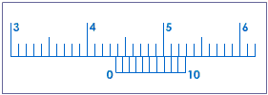
Problem 2:
The accompanying diagram represents a screw gauge. The circular scale is divided in to 50 divisions and the linear scale is divided into millimeters. If the screw advances by 1 mm when the circular scale makes 2 complete revolutions, find the least count of the instrument and the reading of the instrument in figure below.
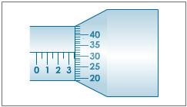

Problem 3:
Calculate the CLA/Ra value for the wave form below.
Short Questions:
- What is the difference between surface texture and integrity?
- Describe roughness, waviness and lay.
- What methods are used for measuring surface roughness?
- Why is an allowance different from a tolerance?

